**Cookie Sales Analysis Report**

**Introduction**

This report aims to dissect cookie sales data across five states: Wisconsin, Utah, Washington, New York, and Alabama. The primary objective is to provide invaluable insights that will enable Divine Foods Inc. to enhance its processes and sales strategies effectively.

This report examines sales data, product performance, and buyer behaviours within the specified date range. By analysing these factors, we aim to unearth actionable insights that will inform executive decision-making and drive sustainable growth for Divine Foods Inc. in the highly competitive cookie market.

Given the diverse regional preferences evident in the sales data, understanding the nuances of consumer tastes and behaviours in each state becomes paramount. Through this analysis, we aim to not only identify the top-performing products but also pinpoint opportunities for optimisation and strategic expansion within each market segment.

As Divine Foods Inc. seeks to improve its processes and sales performance, the findings and recommendations outlined in this report will serve as a roadmap for leveraging strengths, addressing weaknesses, and capitalizing on opportunities. By harnessing the power of data-driven insights, Divine Foods Inc. can position itself for long-term success and market leadership in the cookie business across the aforementioned states.

**Key Findings**

**Revenue and Profit Analysis**

* **Chocolate Chip** cookies lead in total revenue (£13,775), while **Fortune Cookie** shows exceptional cost efficiency, contributing to a high profit margin (57.64%). This illustrates diverse consumer preferences, with Chocolate Chip's popularity and Fortune Cookie's production efficiency standing out.
* 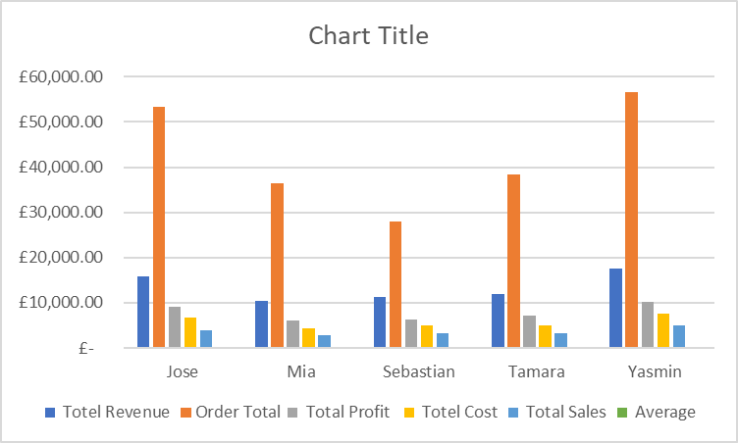**Snickerdoodle** cookies report the highest order total (£41,139), suggesting a high volume of transactions and a solid customer base.
* All cookies maintain a profit margin of over 56%, indicating healthy profitability across the board, with **sugar** cookies achieving the highest margin at 58.59%.

**Buyer Analysis**

* **Yasmin** emerges as the most significant buyer, leading in revenue (£17,628), order total, and total profit (£10,095.95), highlighting her critical role in our sales strategy.
* **Tamara** exhibits the highest profit margin (58.94%), suggesting transactions with Tamara are exceptionally cost-effective or involve high-margin products.

**State Preferences**

* Preferences vary by state, with **White Chocolate Macadamia Nut** favoured in Wisconsin and Alabama and other flavours like **Chocolate Chip**, **Snickerdoodle**, and **Oatmeal Raisin** leading in Utah, Washington, and New York, respectively. This diversity underscores the importance of regional tastes in inventory and marketing strategies.

**Conclusion**

The analysis underscores the need for a balanced approach to cost, pricing, and marketing to maximize profits and market share. By focusing on popular cookies, optimizing profit margins, and tailoring strategies to consumer preferences, we can align our offerings more closely with market demand and financial objectives.

**Recommendations**

1. **Enhanced Focus on Key Products and Buyers**: Increase marketing efforts around popular cookies like Chocolate Chip and Snickerdoodle, and tailor strategies to retain and attract buyers similar to Yasmin.
2. **Profit Margin Optimisation**: Explore cost reduction opportunities for lower-margin cookies without compromising quality, aiming to boost overall profitability.
3. **Premium Positioning**: Leverage the higher average prices of Chocolate Chip and Oatmeal Raisin cookies for premium branding opportunities.
4. **Market Research and Product Development**: Conduct further research to understand the preferences in lower-performing states and develop products or variations to cater to regional tastes.

**Exclusive Summary**

Divine Foods Inc. operates in the competitive cookie market, where understanding customer preferences, optimizing product lines, and enhancing sales strategies are crucial for growth and sustainability. Amidst this landscape, the company faces the challenge of effectively analysing performance across different states to tailor their offerings and operations for better outcomes.

This report presents a comprehensive analysis of our cookie sales, offering key insights into the performance of six different cookie types: Chocolate Chip, Fortune Cookie, Oatmeal Raisin, Snickerdoodle, Sugar, and White Chocolate Macadamia Nut. Through an examination of sales data, costs, profits, profit margins, and buyer behaviours, we identify strategic opportunities to enhance profitability and market positioning.

Our findings reveal a diverse consumer preference landscape, with Chocolate Chip cookies leading in revenue and Fortune Cookies exhibiting remarkable cost efficiency for a high profit margin. The high order volume of Snickerdoodle cookies suggests a strong customer base, while the consistent profit margin above 56% across all cookie types indicates overall healthy profitability. The analysis also highlights significant buyers and state-specific preferences, suggesting tailored marketing and inventory strategies could enhance regional sales.

Top of Form

Bottom of Form